Day in the Life of the Hudson River 10/13/22
Fort Wadsworth, Staten Island, NY
RIVER MILE: -7.5
Salt Front: ~ RM 76
St. Clare School – Mary Lee
50 students & 15 adults
Latitude 40.5976°N & Longitude – 74.0561°W
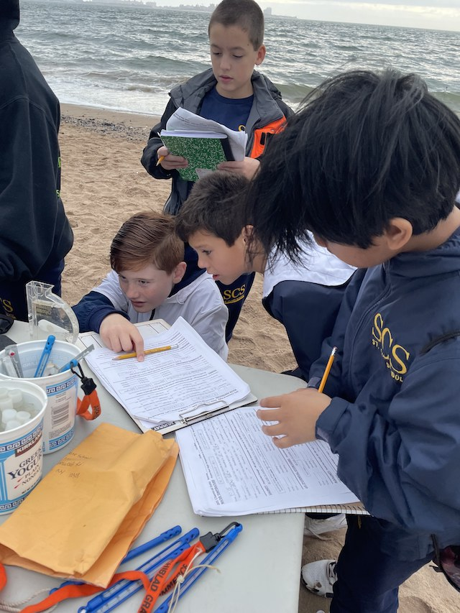 | 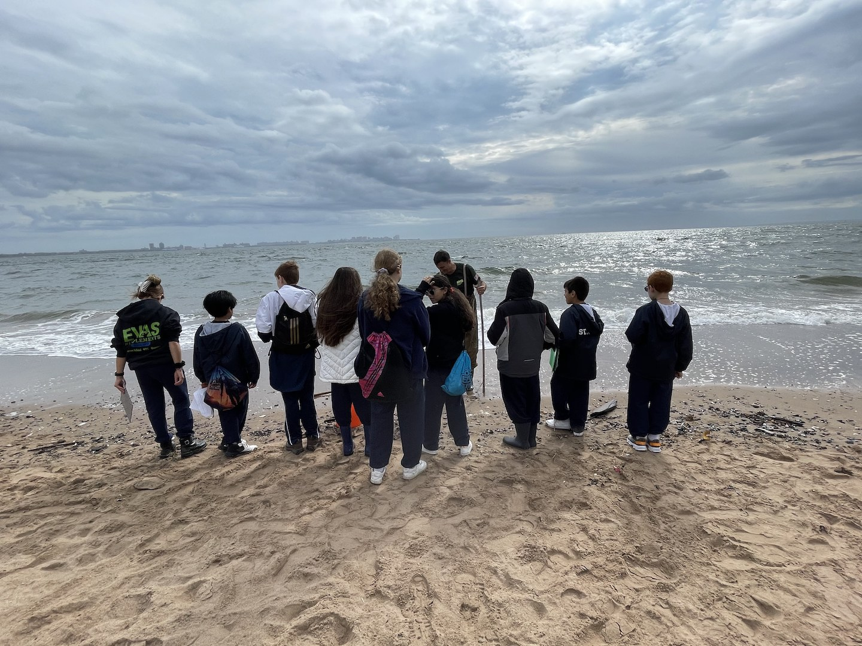 |  | 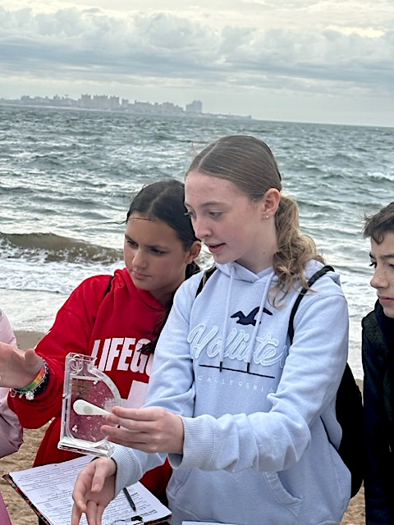
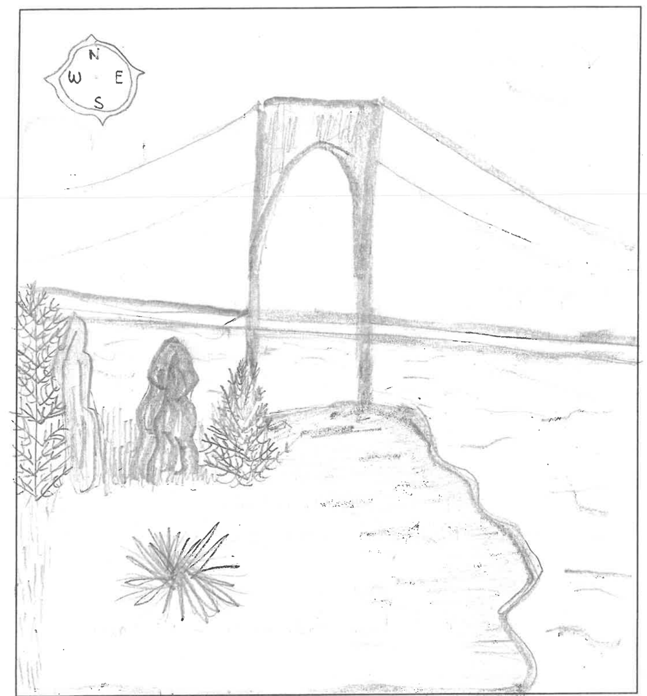
Location: Fort Wadsworth, Staten Island, NY
Area: About a mile south of the Verrazzano- Narrows Bridge
Sampling Site: Pier, forested, beach, grassy, parking lot, covered in vegetation, RipRap (large rocks)
Surrounding Land Uses: 25% Urban/Residential; 25% Forested; 50% Beach
Shoreline: 75% Sandy; 25% Rocky
River Bottom: sandy, rocky, weedy
Water: Choppy
Plants in the Water: No plants in the water
*NR = Not read/recorded
ITEM |  | Time |  | Reading |  |  |  | Comments
Physical
Air Temperature- |  | 10:24 AM  10:30 AM  10:32 AM |  | 19°C  17°C  17°C |  |  | 66.2°F  62.6°F  62.6°F
Wind Speed: |  | 10:25 AM 11:16 AM |  | Anemometer  2.5 knots  6.3 knots |  |  | Beaufort  2  3 | Direction  E  E
Weather today |  | 10:38 AM |  | >75% cloud cover |  |  | No Rain
Weather the past 3 days: |  | 60-70°F for 3 days, fair weather, no rain
Tides- |  | Time |  | Rising, Falling, Unchanged |  |  | Water Height (cm)
 |  | 10:41 AM-11:41 AM |  | Falling |  |  | 85 cm  50 cm
Current- |  | Time |  | Cm/sec |  | Knots | North/South | Ebb/Flood/Still
 |  | 10:49 AM  11:29 AM |  | 3  30.7 |  | 0.06  0.7 | NR  NR | NR  Still
Water Temperature- |  | 11:45 AM |  | 18°C |  |  | 64.4°F
Turbidity- Long Sight Tube (120 cm) |  | 11:33 AM |  | 41.55 cm
Chemical
Salinity-Hydrometer |  | 11:46 AM |  | 29 ppt
Standardized Salinity – Refractometer |  | 10:50 AM |  | 28,000 ppm
DO – Chemets Kit |  | Time  11:41 AM |  | Temp  18°C |  |  | ppm DO  9 ppm | % saturation  95%
pH – Color Match Kit |  | 11:51 AM |  | 8.3
Nitrates- Color Match Kit |  | 11:52 AM |  | 0 ppm
Phosphates- Color Match |  | 11:53 AM |  | 0.15 ppm
Alkalinity- NR
Biological-
Fish – Seine |  | Number |  | Name |  |  | Length of longest | Length of smallest
 |  | 1 |  | Northern Pipefish |  |  | 4.5 cm
Fish Totals |  | TOTAL:1 |  | Diversity: 1
Macroinvertebrates |  | Number |  | Name |  |  | Length of longest | Length of smallest
 |  | 1  44 |  | Asian Shore Crab  Mole Crab |  |  | 2 cm  2 cm | -  0.5 cm
Macroinvertebrate Totals |  | TOTAL: 45 |  | Diversity:2
Sediment Core -
Length | H2S smell |  | Oxid Top |  | Oil |  | Grain Size | Other Features
18 cm | No |  | No |  | No |  | Abundant: sand  Common: gravel, pebbles | Rare: shells, brick
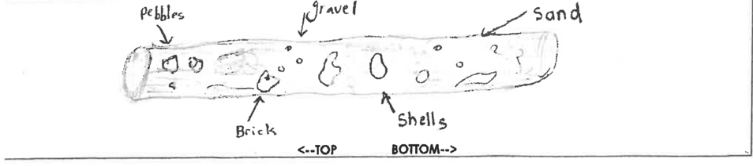
Boats-NA
 | Time |  | Name |  | Color |  | North/Southbound | Light/Loaded
Commercial NR
Recreational

